SET SEARCH_PATH TO CCA,PUBLIC;
SET DATESTYLE=’ISO’,’DMY’;

--A. INSERT Statements--
INSERT INTO LeadCustomer
VALUES
(7,'Jacob','Kelen','21,RiverSide Road,Norwich,UK','JacobK@gmail.com')
ON CONFLICT DO NOTHING;
SELECT * FROM LeadCustomer ORDER BY CustomerID;
;
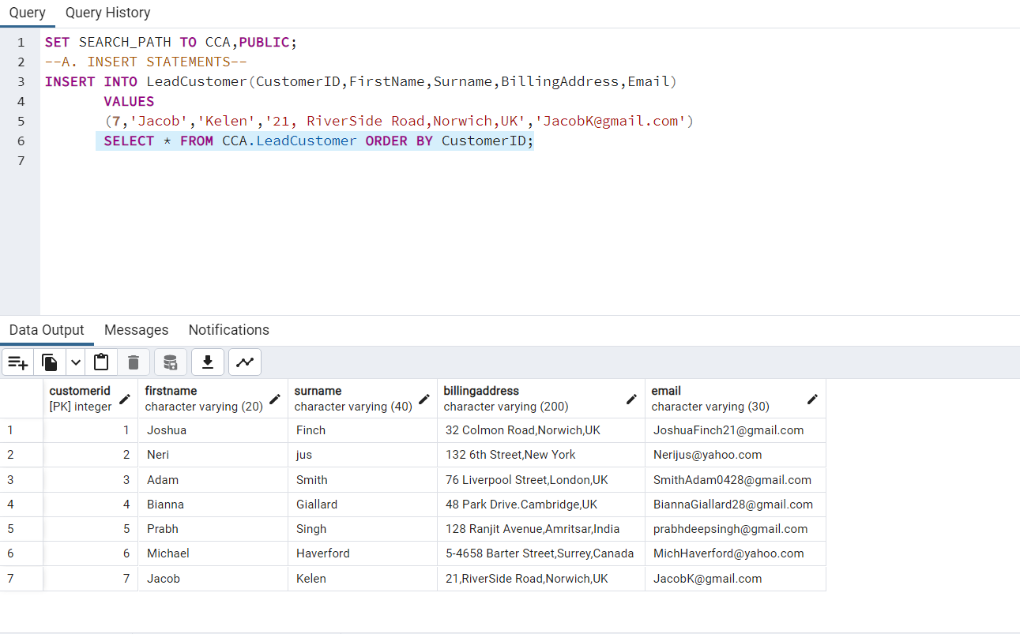
SELECT * FROM LeadCustomer WHERE Surname='Kelen’
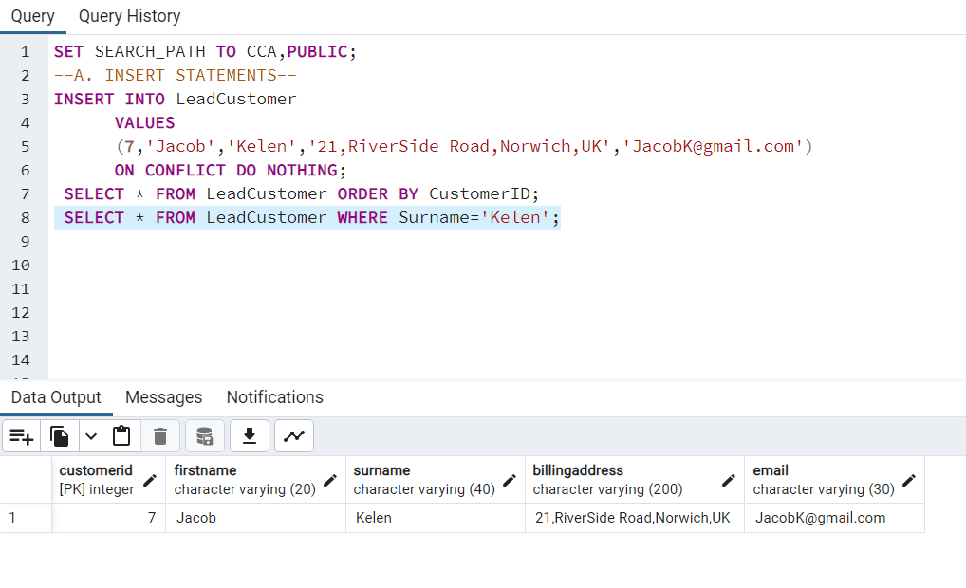

INSERT INTO Passenger
VALUES
(108,'Adam','Smith','W234567','American','30-10-1989') ON CONFLICT DO NOTHING;
SELECT * FROM Passenger WHERE PassengerID=108 AND Nationality='American';
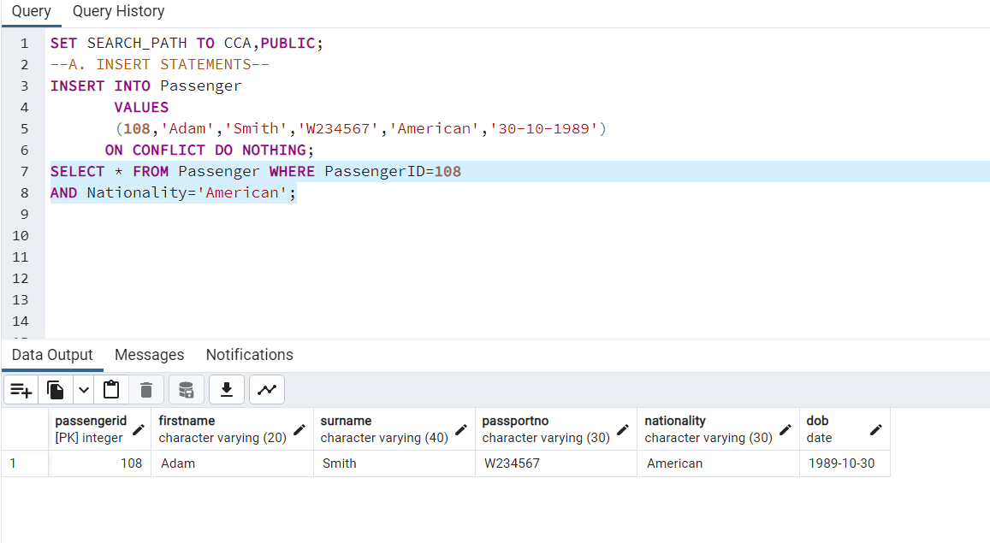

SET DATESTYLE='ISO','DMY';
INSERT INTO Flight
VALUES
(5,'15-10-2023','Vancouver','Paris',312,518)
ON CONFLICT DO NOTHING;
SELECT * FROM Flight ORDER BY FlightID; 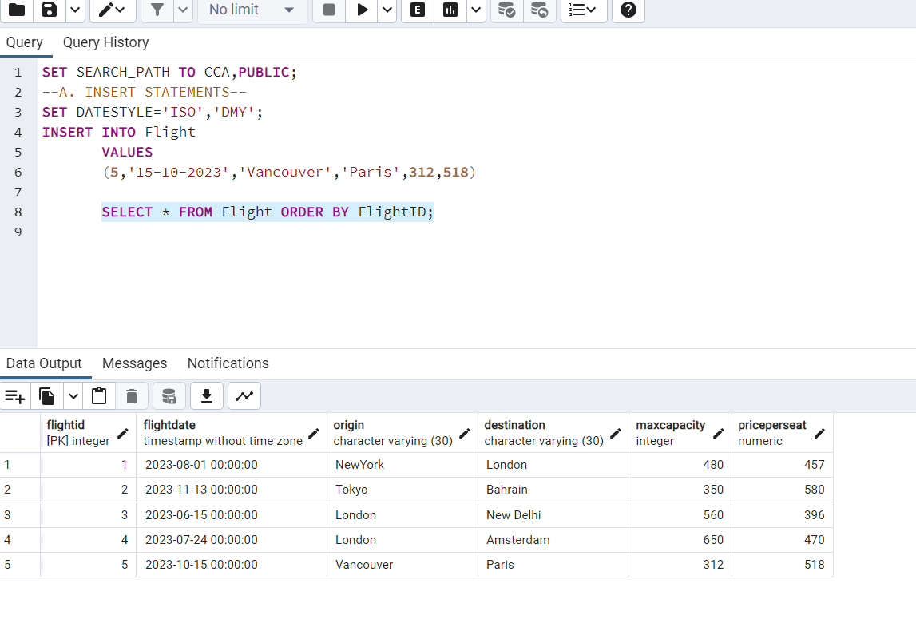
--B.To Delete the Customer record with Given CustomerID but pevent deletion of 'Active'(reserved) booking--
CREATE OR REPLACE FUNCTION NoDeletion()
RETURNS TRIGGER AS $$
BEGIN
IF (SELECT Status FROM FlightBooking WHERE BookingID=OLD.BookingID)='R' THEN
RAISE EXCEPTION 'You cannot delete reserved bookings';
ELSE
IF (SELECT Status FROM FlightBooking WHERE BookingID=OLD.BookingID)='C' THEN
DELETE FROM SeatBooking WHERE BookingID=OLD.BookingID;
DELETE FROM FlightBooking WHERE BookingID=OLD.BookingID;

END IF;
END IF;
RETURN OLD;
END;
$$
LANGUAGE plpgsql;
CREATE TRIGGER NoDeletion BEFORE
DELETE ON CCA.FlightBooking FOR EACH ROW
WHEN (pg_trigger_depth()<1)
EXECUTE FUNCTION NoDeletion();

DELETE FROM FlightBooking WHERE CustomerID=7 AND Status='R';
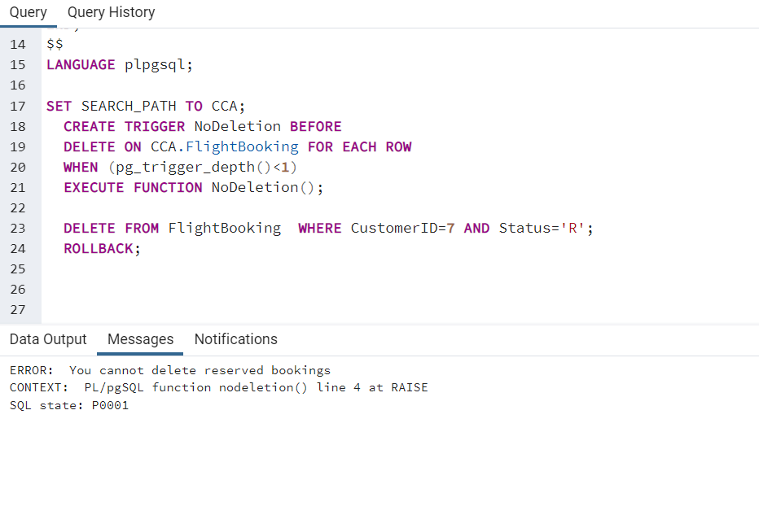
DELETE FROM FlightBooking WHERE CustomerID=2 AND Status='C';

--C. Check Status of Seat--
/*To Calculate and Check 'Available' Status on the current flight information including maximum capacity, reserved and cancelled seats.'*/

SELECT f.FlightID,f.MaxCapacity,b.NumSeats AS Booked,f.MaxCapacity - coalesce(sum(b.NumSeats), 0) AS availableseats
FROM Flight f
LEFT JOIN FlightBooking b
ON f.FlightID = b.FlightID
WHERE b.Status ='R'
GROUP BY f.FlightID,f.MaxCapacity,b.NumSeats;
--Reference:https://stackoverflow.com/questions/43679589--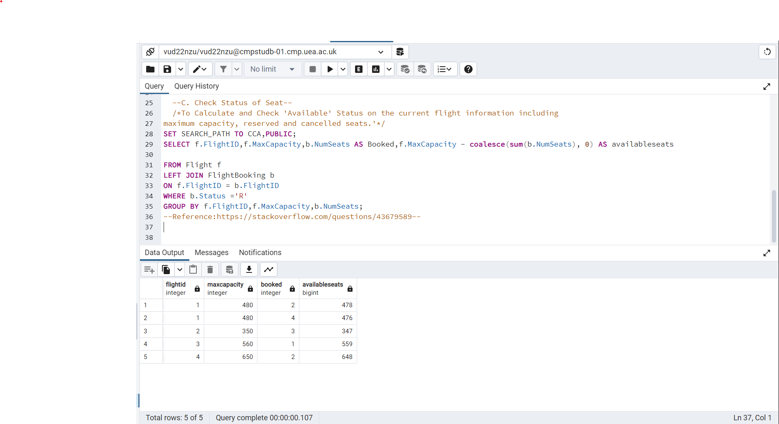
--D. To Check Status of all seats--
SELECT f.FlightID,b.Status, COUNT(*) AS TotalSeats
FROM Flight f RIGHT JOIN FlightBooking b ON f.FlightID=b.FlightID
WHERE b.Status='R' OR b.Status='C' GROUP BY f.FlightID,b.Status; 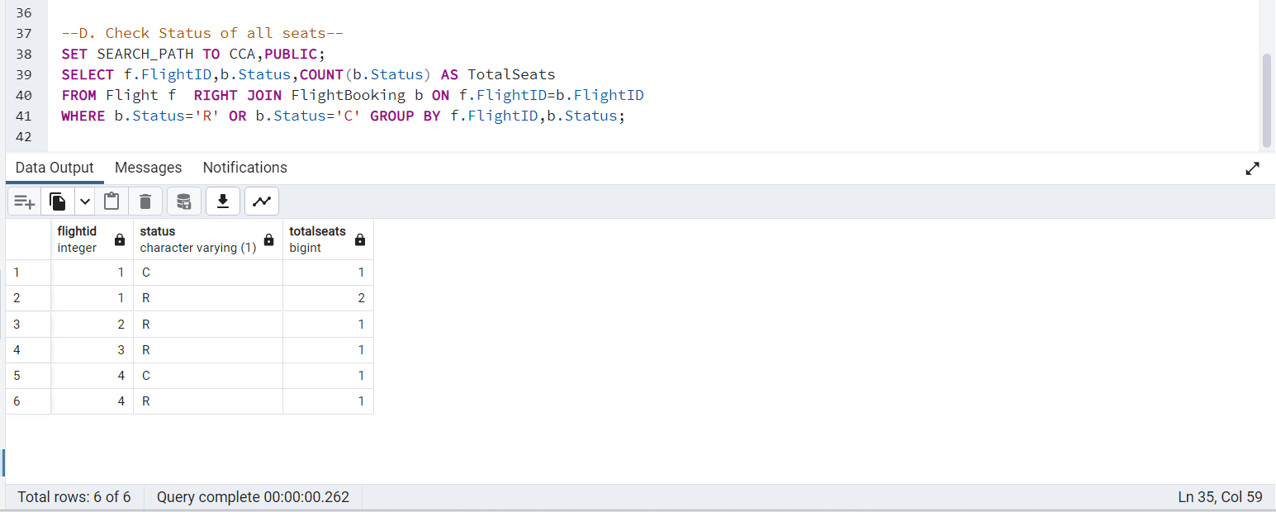

--E. To Produce Ranked list of All Lead customers --
SELECT l.CustomerID,b.BookingID,b.TotalCost, CONCAT(l.FirstName,'',l.Surname) AS FullName
FROM LeadCustomer l INNER JOIN FlightBooking b ON b.CustomerID=l.CustomerID
GROUP BY l.CustomerID,b.BookingID,b.TotalCost
ORDER BY TotalCost DESC;

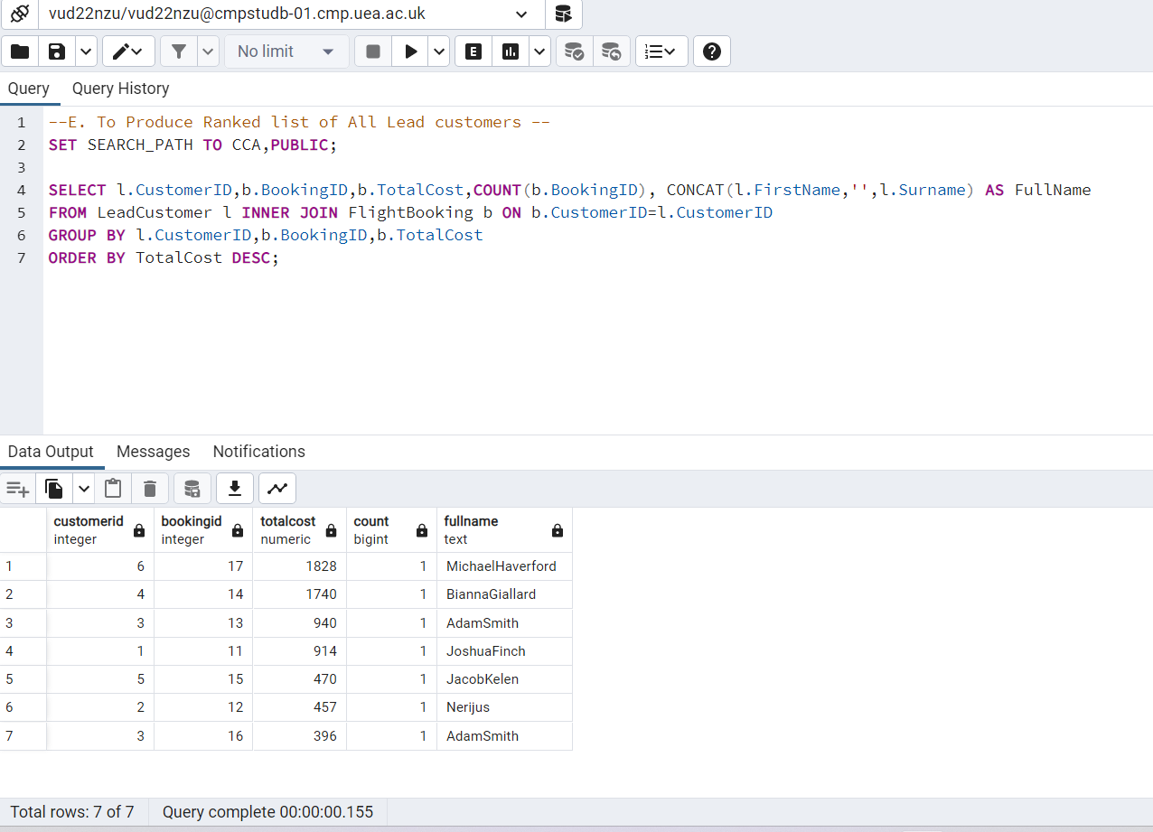

--F. To Make a booking--
SET SEARCH_PATH TO CCA,PUBLIC;
CREATE OR REPLACE PROCEDURE MakeBooking(
BookingID Integer,
CustomerID Integer,
FlightID Integer,
NumSeats Integer,
FirstName varchar(20),
Surname varchar(40),
SeatNumber char(4)
)
LANGUAGE plpgsql
AS $$

BEGIN
SET TRANSACTION ISOLATION LEVEL SERIALIZABLE;
--The Serializable transaction level provides a rigorous guarantee that each transaction sees a wholly consistent view of the database.--
--Reference-Postgresql—

SELECT f.FlightID,f.MaxCapacity,b.NumSeats AS Booked,f.MaxCapacity - coalesce(sum(b.NumSeats), 0) AS availableseats
FROM Flight f LEFT JOIN FlightBooking b
ON f.FlightID = b.FlightID WHERE b.Status ='R'
GROUP BY f.FlightID,f.MaxCapacity,b.NumSeats;

IF (f.MaxCapacity-(COUNT (b.Status='R')))>=b.NumSeats THEN

IF NOT EXISTS(SELECT* FROM LeadCustomer l WHERE l.CustomerID=CustomerID) THEN
INSERT INTO LeadCustomer(CustomerID,FirstName,Surname)
values
(CustomerID,FirstName,Surname);
END IF;

INSERT INTO FlightBooking(BookingID,CustomerID,FlightID,NumSeats,Status)
VALUES
(BookingID,CustomerID,FlightID,RequiredSeats,'R');

INSERT INTO SeatBooking(BookingID,SeatNumber)
VALUES
(BookingID,SeatNumber);
COMMIT;
ELSE
RAISE EXCEPTION 'Sorry!Seats are Unavailable';
END IF;

EXCEPTION
WHEN OTHERS THEN
ROLLBACK;
RAISE NOTICE 'Booking Complete %',BookingID;
--Reference:https://www.postgresql.org/docs/12/sql--
END;

$$;
CALL MakeBooking(19,9,5,1,'Sneha','Katyal','20G');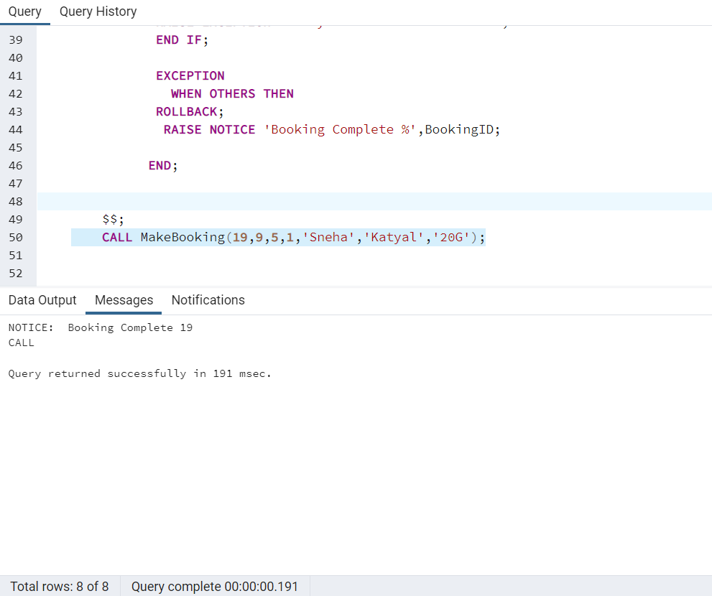

--G. Cancel the booking for given BookingID, but not deleting record--
UPDATE CCA.FlightBooking
SET Status='C' WHERE BookingID=16;
SELECT*FROM CCA.FlightBooking WHERE Status='C';
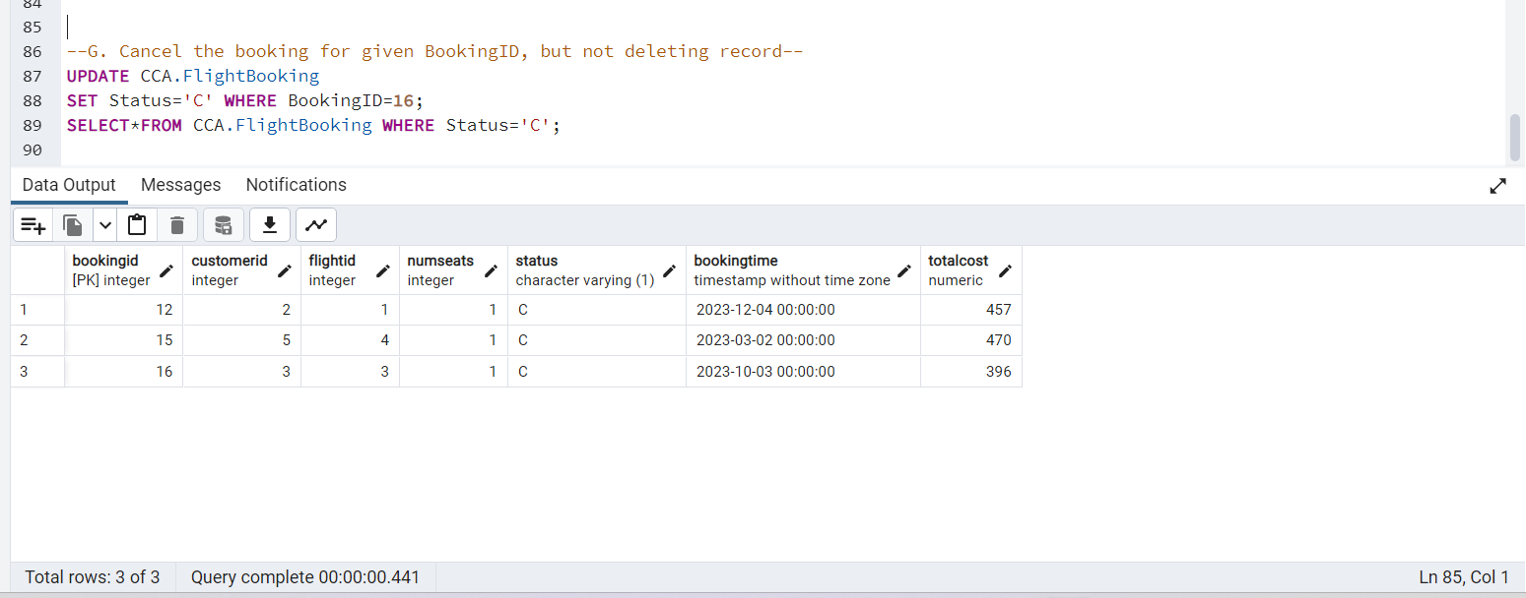

--Test Query For Trigger Update_Cost –
CREATE OR REPLACE FUNCTION CCA.update_TotalCost()
RETURNS TRIGGER AS $$
BEGIN
UPDATE CCA.FlightBooking SET TotalCost=b.NumSeats*(SELECT PricePerSeat FROM CCA.Flight f WHERE f.FlightID=b.FlightID)
FROM CCA.FlightBooking b INNER JOIN CCA.Flight f ON b.FlightID=f.FlightID
WHERE b.BookingID=NEW.BookingID AND Status='R';
RETURN NEW;
END;
$$
LANGUAGE plpgsql;

CREATE TRIGGER update_TotalCost_trigger
AFTER INSERT ON FlightBooking
FOR EACH ROW
EXECUTE FUNCTION update_TotalCost();
SELECT * FROM FlightBooking;
